2016 Dazzling Daylilies Festival
Annual Daylily Sale
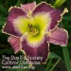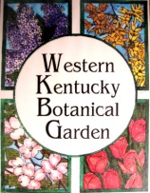
Saturday June 25 – 8 A.M. – 1 P.M.
There is a large Daylily Dig Bed with many different cultivars. The labels have been lost on most of these.
A select group of named and labeled hybrid Daylilies IS available from which to dig.
There are potted plants also available for sale.
The Daylilies for sale are from The Garden’s Collection of over 600 cultivars. The inventory is available, on request, for email distribution.
Prices range from $10 to $50.
WESTERN KENTUCKY BOTANICAL GARDEN
25 Carter Road Owensboro, KY 42301 270-852-8925
wkbg@bellsouth.net www.wkbg.org

